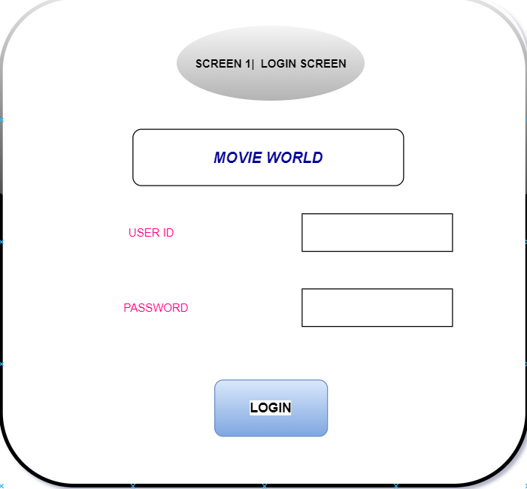

void login_screen(){

int i=0;

char user_id[51],password[51],ch;

clrscr();

go(5,20);printf("welcome to movie world");

go(10,20);printf("User ID");

go(12,20);printf("password");

go(10,30);gets(user_id);

go(12,30);

fflush(stdin);

while(i<50){

ch=getch();

if(ch==13)break;

else if(ch==8)

{

if(i>0){

int n;

i--;

go(12,30);clreol();

for(n=0;n<i;n++) putchar('*');

}

}

else{

password[i]=ch;

putchar('*');

i++;

}

}

password[i]='\0';

if(strcmp(user_id,"movie world")==0 && strcmp(password,"1234")==0)

{

setup();

}

else

{

go(20,20);printf("invalid user or password");

go(21,20);printf("press any key to continue..");

getch();

}

}

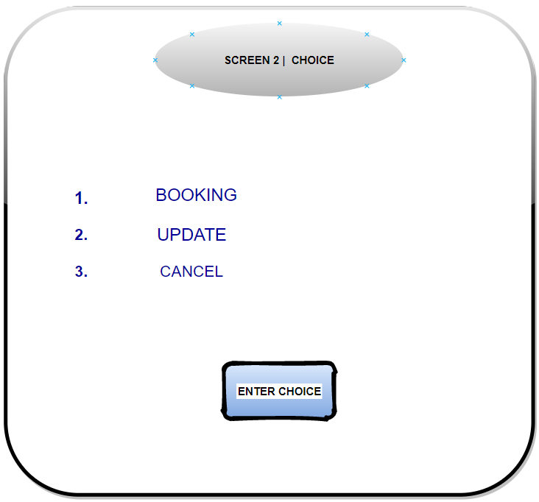

void setup(){int m=10,n=51,i,j,a=0,b=0,c=0,option=0;

clrscr();

printf(" ********************* MAIN MENU *********************\n\n");

printf(" ######## WELCOME TO MAK CINEMAS #######\n");

for(i=0;i<m;i++)

{

for(j=0;j<n;j++)

{

if(j==12||j==n-1||(i==m-1 && j>=12))

printf("#");

else if(i==1&&a==0)

{

printf(" #1. BOOKING");

j+=22;

a++;

}

else if(i==4&&b==0)

{

printf(" #2. UPDATE");

j+=21;

b++;

}

else if(i==7&&c==0)

{

printf(" #3. CANCEL");

j+=21;

c++;

}

else

printf(" ");

}

printf("\n");

}

printf("PLEASE SELECT AN OPTION FROM THE ABOVE MENU");

scanf("%d",&option);

switch(option){

case 1:booking();break;

case 2:update();break;

case 3:cancel();break;

case 4:exit(0);

}

if(option==1)

{

booking();

}

else if(option==2)

{

update();

}

else

{

printf("invalid choice");

}

}

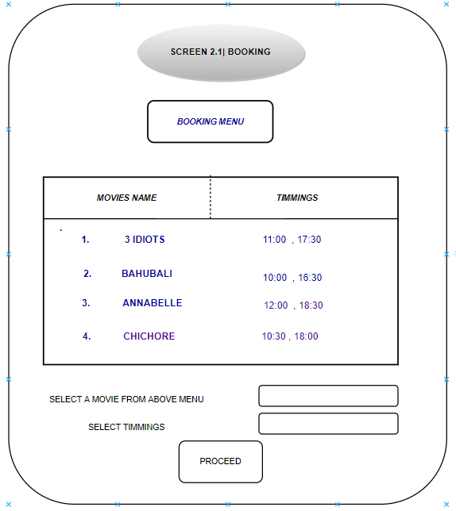

void booking(){int m=10,n=51,i,j,a=0,b=0,c=0,d=0;

char slot[2],movie[2];

clrscr();

printf(" ********************* BOOKING MENU *********************\n\n");

printf(" #### MOVIES ############## TIMINGS ####\n");

for(i=0;i<m;i++)

{

for(j=0;j<n;j++)

{

if(j==12||j==n-1||(i==m-1 && j>=12))

{

printf("#");

}

else if(i==1&&a==0)

}

printf(" #1) 3 Idiots 11:00 , 17:30");

j+=46;

a++;

}

else if(i==3&&b==0)

{

printf(" #2) Bahubali 10:00 , 16:30");

j+=46;

b++;

}

else if(i==5&&c==0)

{

printf(" #3) Annebelle 12:00 , 18:30");

j+=49;

c++;

}

else if(i==7&&d==0)

{

printf(" #4) Chhichhore 10:30 , 18:00");

j+=49;

d++;

}

else

printf(" ");

}

printf("\n");

}

printf("movie: ");

scanf("%d",&movie);

printf(" slot: ");

scanf("%d",&slot);

}

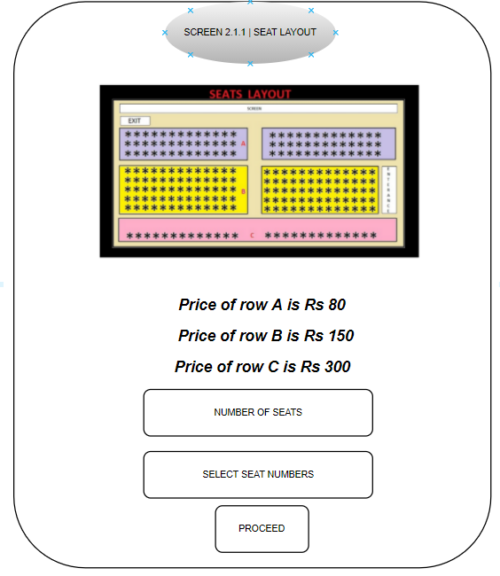

void seat_layout(){

char no_of_seats[51],seat_no[51],proceed[51];

go(5,30);printf("seat layout");

go(15,30);printf(" Price of row A is Rs 80");

go(16,30);printf(" Price of row B is Rs 150");

go(17,30);printf(" Price of row C is Rs 300");

go(20,20);printf("enter of seats");

go(20,50);gets(no_of_seats);

go(22,20);printf("select seat numbers");

go(22,50);gets(seat_no);

go(25,20);printf("click p to proceed: ");

go(25,50);gets(proceed);

if(strcmp(proceed,"p")==0){

}

else

{

clrscr();

go(10,30);printf("press only p to continue");

getch();

}

}

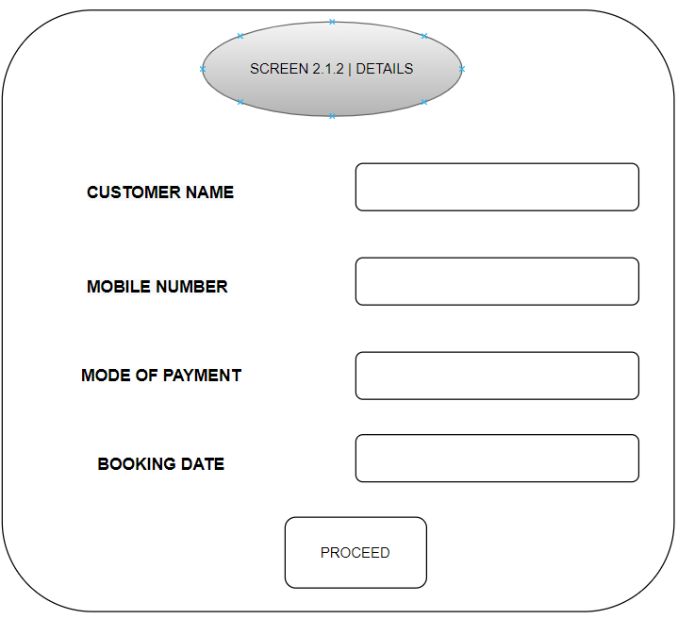

char customer_name[51],proceed[21],booking_date[51],mobile_no[51],mode_of_payment[51];

clrscr();

go(5,25);printf("customer details");

go(8,10);printf("customer name");

go(8,30);gets(customer_name);

go(16,10);printf("mobile number");

go(16,30);gets(mobile_no);

go(18,10);printf("booking date");

go(18,30);gets(booking_date);

go(20,10);printf("mode of payment");

go(20,30);gets(mode_of_payment);

go(25,10);printf("click p to proceed: ");

go(25,40);gets(proceed);

if(strcmp(proceed,"p")==0)

{

}

else

{

clrscr();

go(15,30);printf("press only p to continue");

}

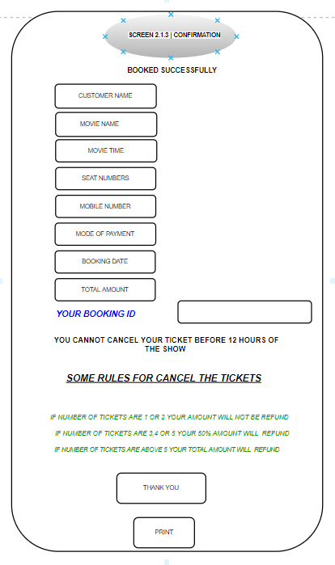

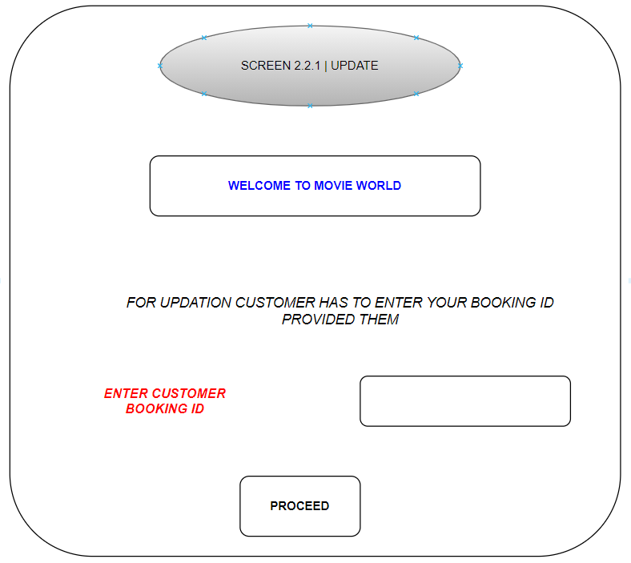

void update(){

char user_id[51];

clrscr();

go(10,30);printf("WELCOME TO MOVIE WORLD");

go(12,15);printf("For updation customer has to enter the booking id provided them");

go(15,20);printf("user_id");

go(15,30);gets(user_id);

if(strcmp(user_id,"movie")==0)

{

old_details();

}

else

{

go(20,20);printf("invalid user");

go(22,20);printf("press any key to continue");

}

}

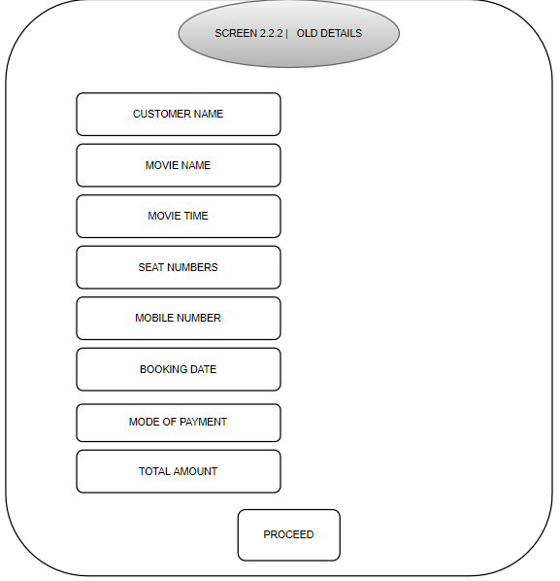

void old_details(){

char movie_name[51],seat_numbers[51],customer_name[51],proceed[21],movie_time[51],mobile_no[51],booking_date[51],total_amount[51],mode_of_payment[51],p;

clrscr();

go(5,25);printf("customer details");

go(8,10);printf("customer name");

go(8,30);gets(customer_name);

go(10,10);printf("movie name");

go(10,30);gets(movie_name);

go(12,10);printf("movie time");

go(12,30);gets(movie_time);

go(14,10);printf("seat numbers");

go(14,30);gets(seat_numbers);

go(16,10);printf("mobile number");

go(16,30);gets(mobile_no);

go(18,10);printf("booking date");

go(18,30);gets(booking_date);

go(20,10);printf("mode of payment");

go(20,30);gets(mode_of_payment);

go(22,10);printf("total amount");

go(22,30);gets(total_amount);

go(25,15);printf("click p to proceed: ");

go(25,25);gets(proceed);

if(strcmp(proceed,"p")==0)

{

seats();

}

else

{

go(24,20);printf("press p only");

go(25,20); printf("press any key to continue..");

getch();

}

}

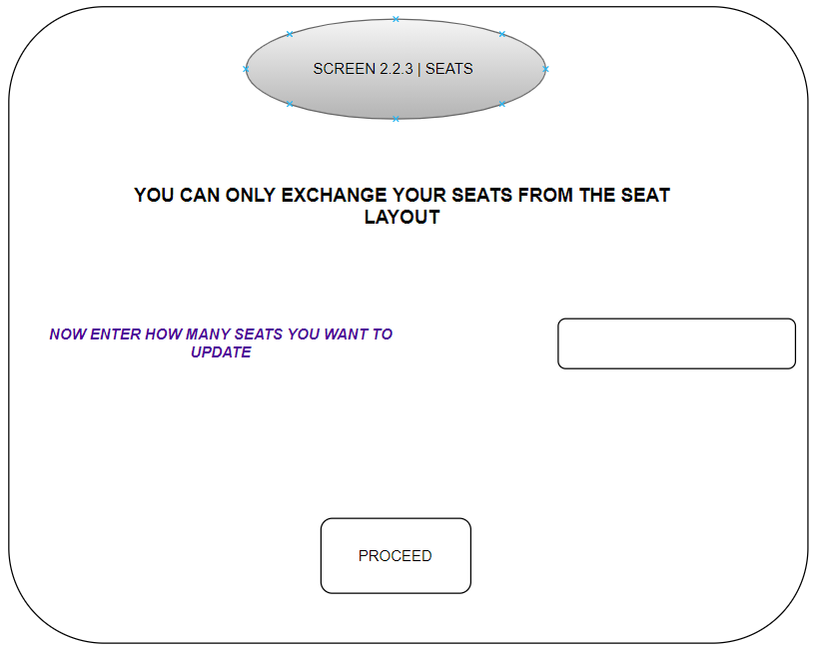

void seats(){

char seats[51],proceed[51];

clrscr();

go(5,30);printf("seats");

go(8,1);printf("You can only exchange your seats from the seat layout");

go(12,2);printf("Now enter seats numbers you want to update from your printed ticket");

go(12,73);gets(seats);

go(20,15);printf("click p to proceed: ");

go(20,40);gets(proceed);

if(strcmp(proceed,"p")==0)

{

}

else

{

go(24,20);printf("press p only");

go(25,20); printf("press any key to continue..");

getch();

}

}

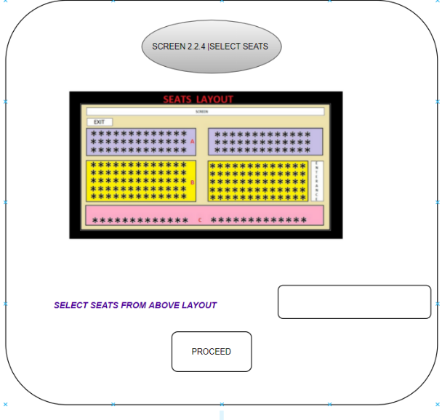

Void select_seats(){

char seats[51],proceed[21];

clrscr();

go(5,30);printf("seat layout");

go(20,15);printf("select seats from above layout");

go(20,45);gets(seats);

go(25,15);printf("click p to proceed: ");

go(25,40);gets(proceed);

if(strcmp(proceed,"p")==0)

{

}

else

{

go(24,20);printf("press p only");

go(25,20); printf("press any key to continue..");

getch();

}  
}

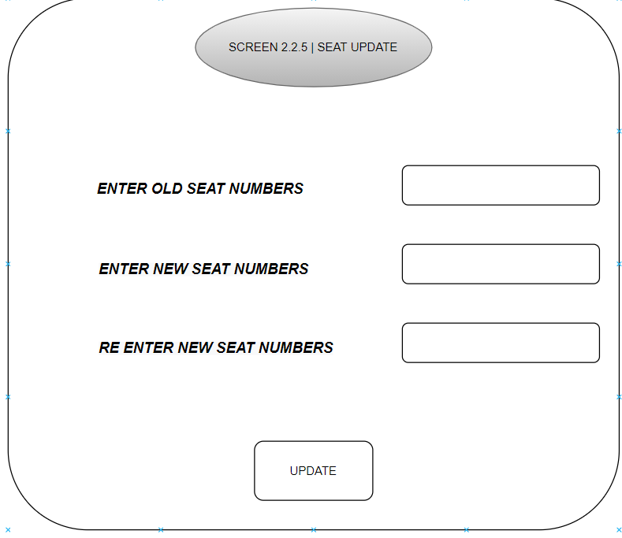

void seat_update(){

char old_seat_no[51],new_seat_no[51],update[21];

clrscr();

go(8,30);printf("seat updation");

go(15,20);printf("enter old seat numbers");

go(15,45);gets(old_seat_no);

go(17,20);printf("enter new seat numbers");

go(17,45);gets(new_seat_no);

go(19,20);printf("re-enter new seat numbers");

go(19,45);gets(new_seat_no);

go(25,15);printf("click u to update: ");

go(25,40);gets(update);

if(strcmp(update,"u")==0)

{

new_details();

}

else

{

go(24,20);printf("press p only");

go(25,20); printf("press any key to continue..");

getch();

}

}

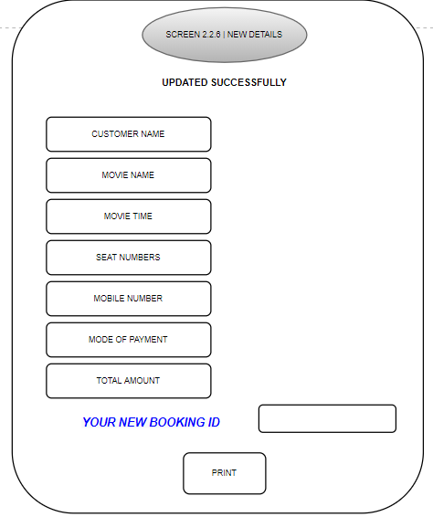

void new_details(){

char customer_name[51],movie_name[51],booking_date[51],new_booking_id[51],proceed[51],movie_time[51],seat_numbers[51],mobile_no[51],mode_of_payment[51],total_amount[51],booking_id[51];

clrscr();

go(3,30);printf("UPDATE SUCCESSFULLY");

go(5,10);printf("customer name");

go(5,30);gets(customer_name);

go(7,10);printf("movie name");

go(7,30);gets(movie_name);

go(9,10);printf("movie time");

go(9,30);gets(movie_time);

go(11,10);printf("seat numbers");

go(11,30);gets(seat_numbers);

go(13,10);printf("mobile number");

go(13,30);gets(mobile_no);

go(15,10);printf("booking date");

go(15,30);gets(booking_date);

go(17,10);printf("mode of payment");

go(17,30);gets(mode_of_payment);

go(19,10);printf("total amount");

go(19,30);gets(total_amount);

go(21,17);printf("your new booking id");

go(21,40);gets(new_booking_id);

go(25,15);printf("click p to proceed: ");

go(25,40);gets(proceed);

if(strcmp(proceed,"p")==0)

{

seats();

}

else

{

go(24,20);printf("press p only");

go(25,20); printf("press any key to continue..");

getch();

}

}

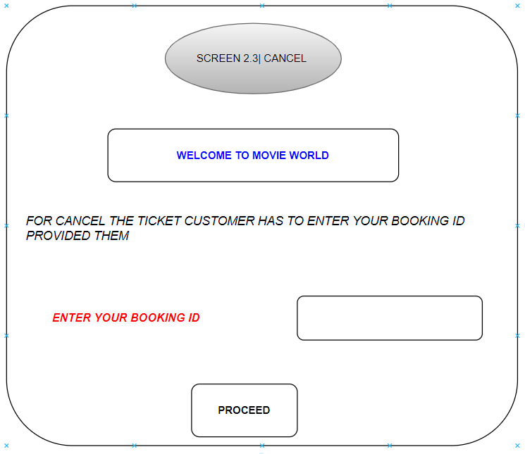

void cancel(){

char booking_id[51];

clrscr();

go(10,30);printf("WELCOME TO MOVIE WORLD");

go(12,15);printf("For cancelation customer has to enter the booking id provided them");

go(15,20);printf("booking_id: ");

go(15,35);gets(booking_id);

if(strcmp(booking_id,"movie")==0)

{

}

else

{

go(20,30);printf(“invalid user id”);

getch();

}

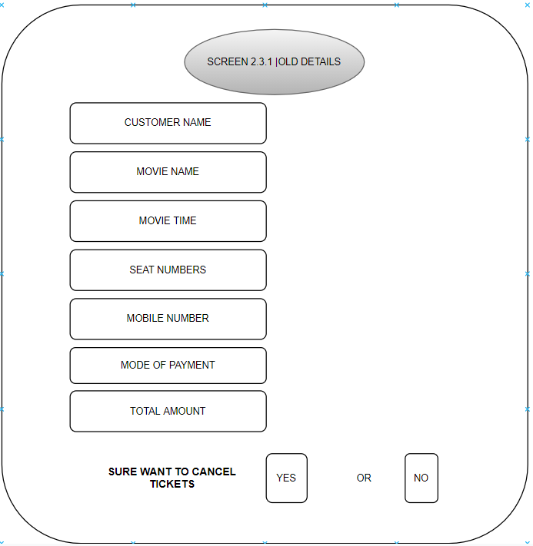

char movie_name[51],seat_numbers[51],customer_name[51],proceed[21],movie_time[51],mobile_no[51],booking_date[51],total_amount[51],mode_of_payment[51],p;

clrscr();

go(5,25);printf("customer details");

go(8,10);printf("customer name");

go(8,30);gets(customer_name);

go(10,10);printf("movie name");

go(10,30);gets(movie_name);

go(12,10);printf("movie time");

go(12,30);gets(movie_time);

go(14,10);printf("seat numbers");

go(14,30);gets(seat_numbers);

go(16,10);printf("mobile number");

go(16,30);gets(mobile_no);

go(18,10);printf("booking date");

go(18,30);gets(booking_date);

go(20,10);printf("mode of payment");

go(20,30);gets(mode_of_payment);

go(22,10);printf("total amount");

go(22,30);gets(total_amount);

go(25,10);printf("sure want to cancel tickets: 'yes' or 'no' ");

go(25,65);gets(proceed);

if(strcmp(proceed,"yes")==0)

{

}

else

{

go(20,30);printf(“invalid option”);

go(22,30);printf(“press any continue to continue”);

getch();

}

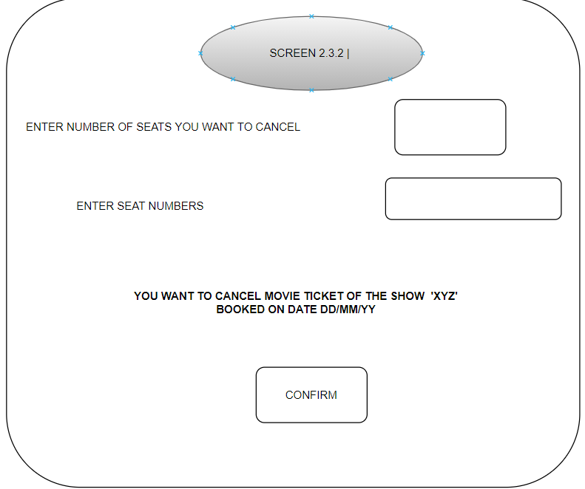

char seats[51],proceed[51];

clrscr();

go(5,30);printf("seats");

go(8,1);printf("enter number of tickets you want to cancel: ");

go(12,2);printf("enter seat numbers : ");

go(12,25);gets(seats);

go(25,15);printf("click c to cancel ");

go(25,40);gets(proceed);

if(strcmp(proceed,"c")==0)

{

}

Else

{

go(20,30);printf(“press only c to continue”);

getch();

}

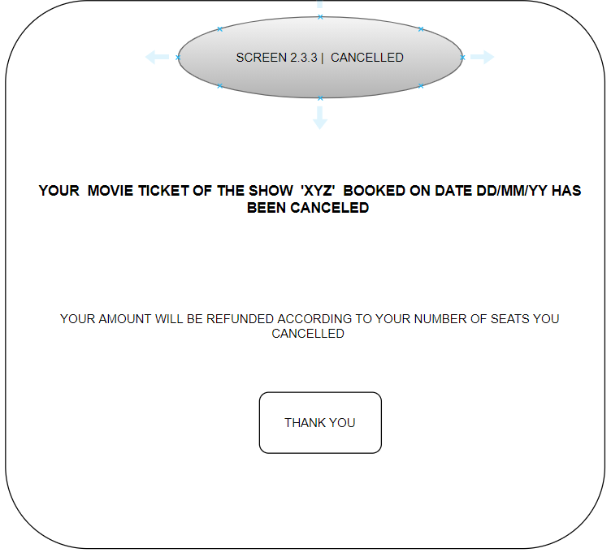

char confirm[51];

clrscr();

go(5,10);printf("your movie ticket of the show xyz on date ...... has been cancelled");

go(10,15);printf("your amount wil be refunded according to your number of seats or number of tickets you cancelled");

go(15,30);printf(" THANK YOU ");

getch();

}

else

{

clrscr();

go(15,30);printf("click only c to confirm cancelation");

go(20,30);printf("press any key to continue..");

getch();

}